Pokhara University

Level: Bachelor | Semester – Fall | Year : 2011
Programme: BE |  | Full Marks: 100
Course: Network Theory |  | Pass Marks: 45
 |  | Time : 3hrs.

Candidates are required to give their answers in their own words as far as practicable.
The figures in the margin indicate full marks.

Attempt all the questions.

 | - For the network shown in figure below, determine the voltage response of the circuit when the switch is opened at t = 0.  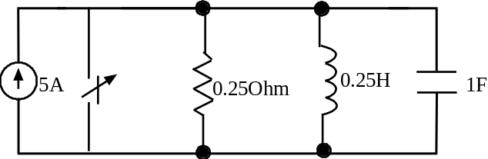  - An R-L circuit is connected to an ac voltage v(t) = 100sin (500t + 30) volts at t = 0, R = 5Ω  and L = 0.01 H. Find the equation for the current using classical method. Also find the value of circuit current at t = 0.01sec.  K  5  O  h  m  0  .  0  1  H  v  (  t  )  =  1  0  0  s  i  n  (  5  0  0  t  +  3  0  )  i  (  t  )  t  =  0 | 7  8
 | - At t = 0, the switch K is opened. Determine v(0+), dv/dt(0+), d²v/dt²(0⁺).  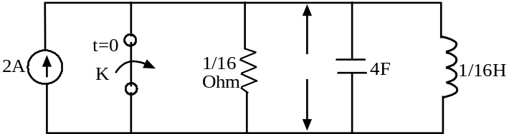  V  - Switch K is closed at t = 0. Find the time domain circuit current using Laplace transform for the following circuit:  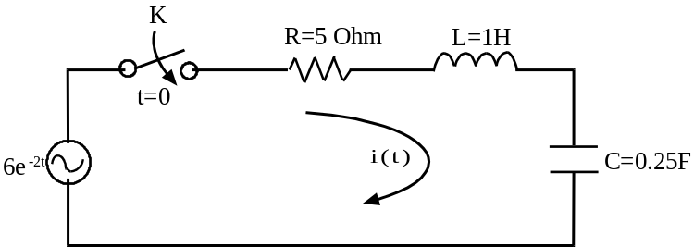 | 7  8
 | - What do you mean by transfer function of a system? The characteristic polynomial of a system is by s³+2s²+4s+k = 0. Apply Routh Hurwitz criterion to determine the range of k for this system to be stable.  - Define transfer function. For the network shown below determine V₂(s)/V₁(s).  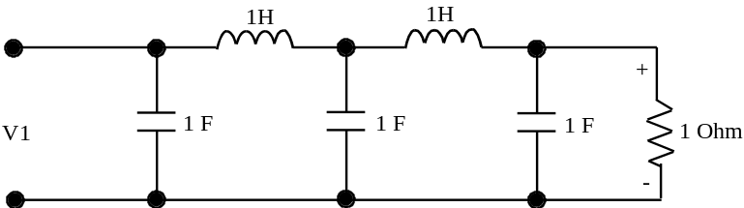  V₂ | 7  8
 | - Determine the Fourier transform of a pulse of duration Td and amplitude V as shown in figure below:  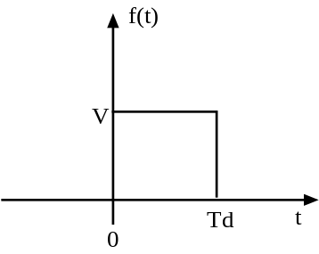  - Plot the straight line asymptotic magnitude response 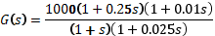 | 7  8
 | - Determine whether the following is a positive real function: 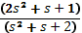.  - Synthesize the given impedance function in Foster-I and II forms:  Z(S) = [8(s²+4)(s²+25)]/[s(s²+16)] | 7  8
 | - For the network shown, find the Z and Y parameters.  +  V₂  –  +  V₁  –  3Ω  2Ω  I₁  1Ω  I₂  - Find the equivalent T network for the given ∏ network.  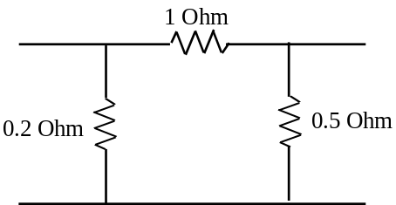 | 7  8
 | Write short notes on any two:  - Properties of RL and RC network  - Classification of filters  - Symmetry and reciprocity of the network | 2×5

